Details to be shared for white labelled platform

General Details:
- WABA onboarding form (attached)
- Brand Logo (100 * 33 in 3:1 ratio) :https://www.gtechwebmarketing.com/storage/downloads/logo-black-1.png
- Favicon: (Image format: ICO; Maximum file size: 100KB):https://www.gtechwebmarketing.com/storage/downloads/logo-black-1.png
- URL Redirection:https://gtechies.in/
- SSL Certificate:
- Domain Name:https://gtechies.in/
- Point your domain to our public IP (103.207.100.105) address:
- Billing Currency (INR, USD) Only one currency to be mentioned:
- Platform login Mail ID:

WABA Onboarding: (If you are a META TSP, we will need your TSP details)
- TSP App ID: 740456408434179
- TSP Solution ID:
- System User Access Token:61575557400092
Steps to find System User Token: 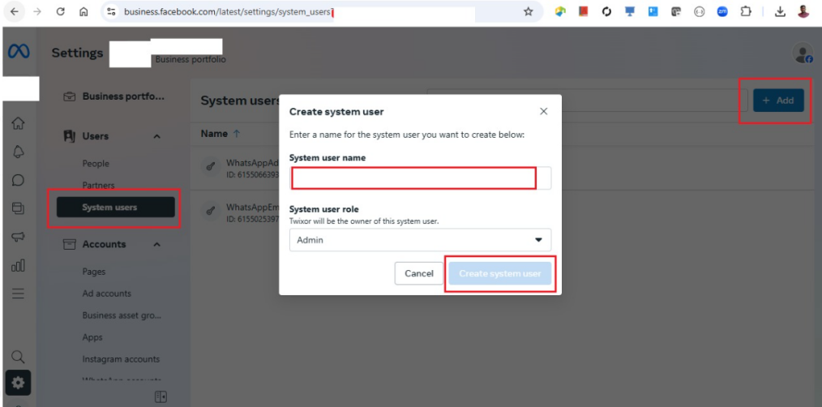
- Meta App Client Secret:ec9fa35ba97d6560c56adfc2bf898a44
Steps to find Client Secret:
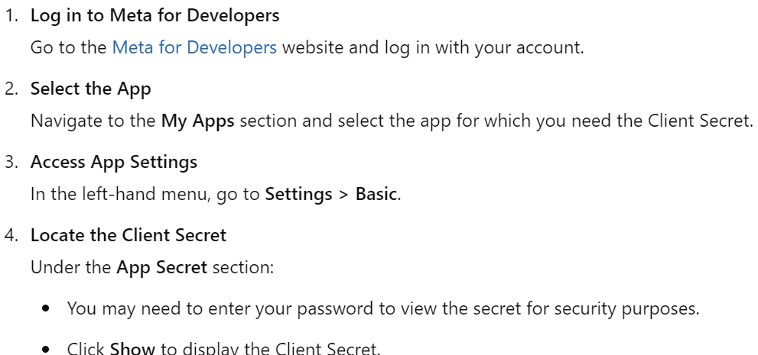

- Meta Application Configuration ID: 747029367744077

Steps to find Configuration ID:
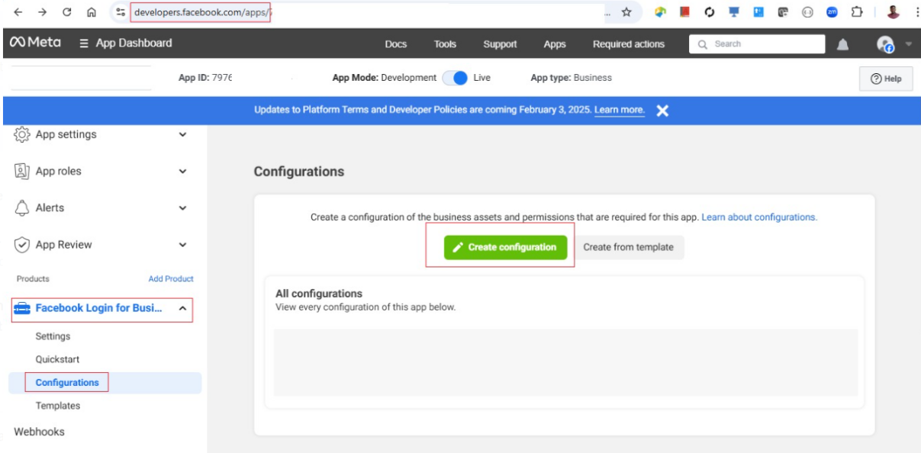
Note: If you don’t want to be a TSP then will use the Karix embedded signup.

Email Notification:
- The customer should share their ISV Mailchimp account details.
- Mailchimp account creds (Email ID, Email Name, Subaccount Name, API key) for sending account activation link and other communication emails.
- Email ID:
- Email Name:
- Subaccount Name:
- API key:

